Streetka window Fitting Instructions:

**EASIER WITH 2 PEOPLE**
Start by Opening roof about 10"
From the inside, lift the velcro covering the zip at the top in the middle & use a screwdriver / pliers to remove the metal clamp.
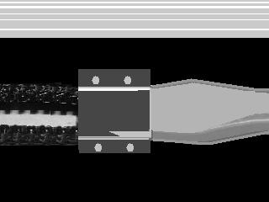
Using a screwdriver, open up the zip.
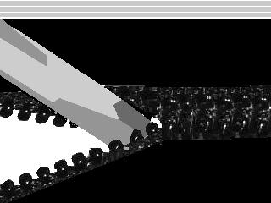
The screen is held in with strong tape... gently pull out the screen.
Install the new screen from inside of the car...
Be sure to start the zip in the correct position by correctly lining up the tabs.
zip in the new screen with the slider provided.

Once zipped in, use the needle provided to tie a few loops.
This stops the zip from opening.

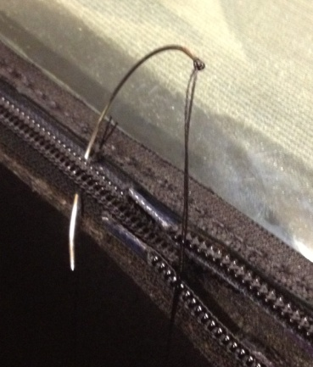
Now please close the roof tight.
You then need to peel back the double sided venture tape & press the canvas trim that overlaps the screen firmly into place.
Hood canvas MUST be clean & dry.

VENTURE TAPE NEEDS A VERY TIGHT SQUEEZE FOR IT TO WORK PROPERLY
( 1 PERSON INSIDE / 1 PERSON OUTSIDE )

DO NOT DROP HOOD FOR 24 HOURS AFTER FITTING.

